- Download the three template files created by K1REZ. These will likely download to your Downloads folder specific to your windows user. For my user “kyle” that file path is “C:\Users\kyle\Downloads”
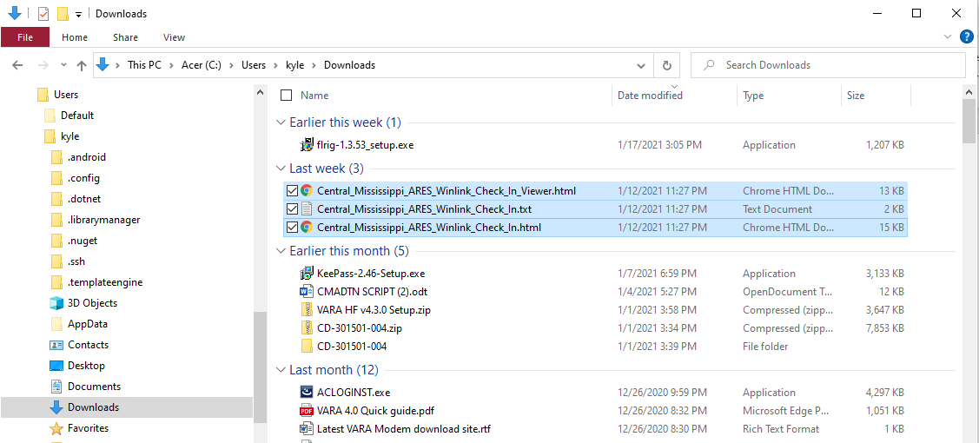

- Find your RMS Express installation folder. I believe the default is “C:\RMS Express”. From there you need to find the templates folder and copy the files there. There are two options either the “Global Folders” or a folder specific to your callsign. I chose the global folders. Under there you will find the “Templates” folder. This results in a target folder path of “C:\RMS Express\Global Folders\Templates”. After copying the download files to this location, it should look like the screenshot below.
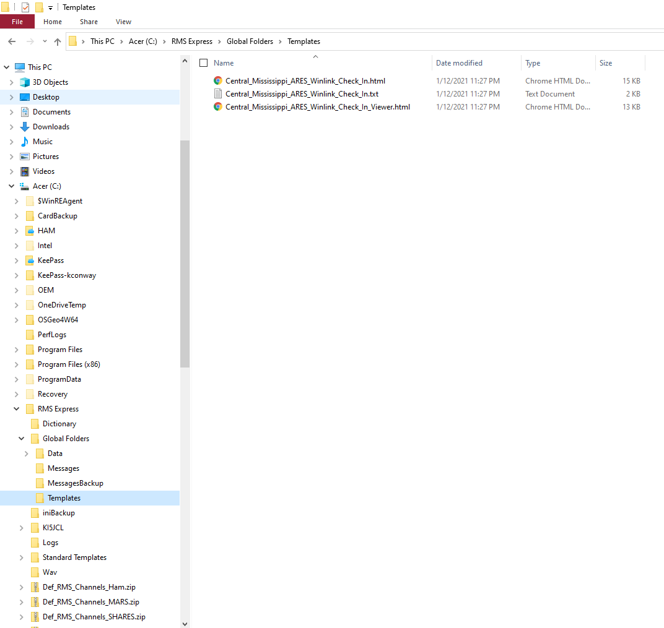

- Now open up Winlink Express as normal.
- To verify the template is installed from the “Message” menu select “Templates”.
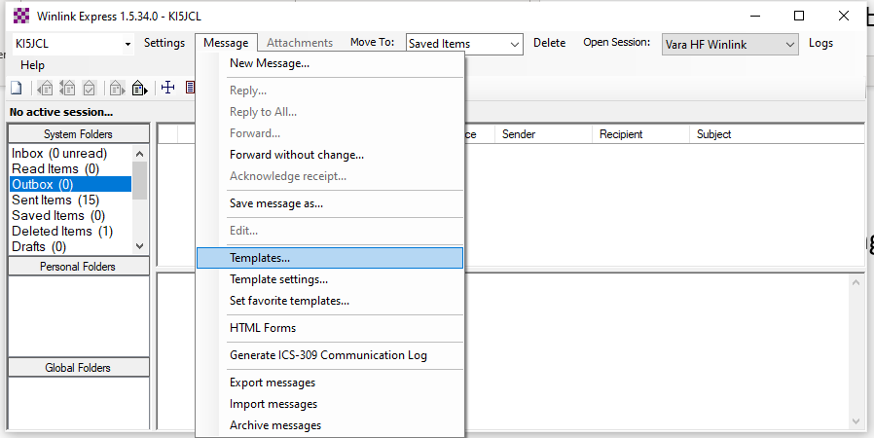
- From here you should be able to expand “Global Templates” and see an entry for the new template.
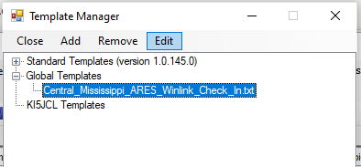
- Now close the Template Manager window and select the “Message” menu and select “HTML Forms”
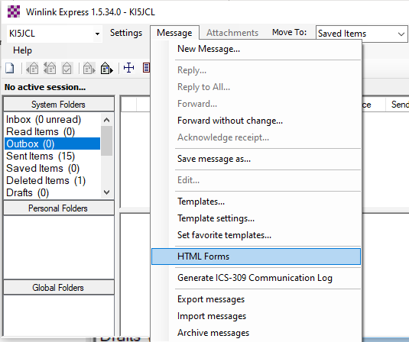
- In the HTML Forms manager window, expand the “Global Forms” and you should see 2 forms. One is the “In” or input version of the form and the other is a read only “Viewer” version of the form.
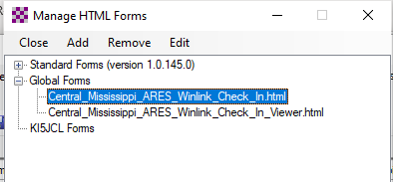
- If everything checks out up to this point, the template and forms are installed. It is time to use them. Select the “New Message” option from the main window.
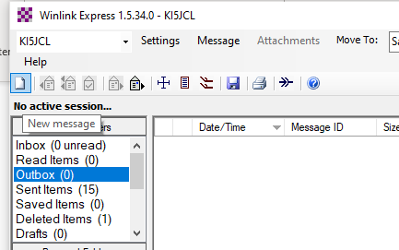

- From the message window click on “Select Template”

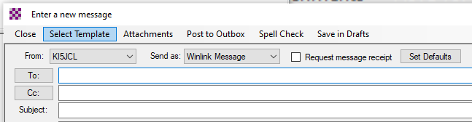

- Highlight the template, then click “Select” (or just double click the template)
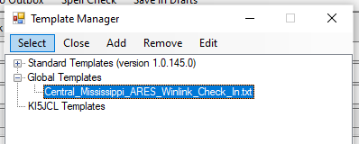

- At this point the input form will open in the browser and allow you to fill in the information. Once filled in, click the submit at the bottom.
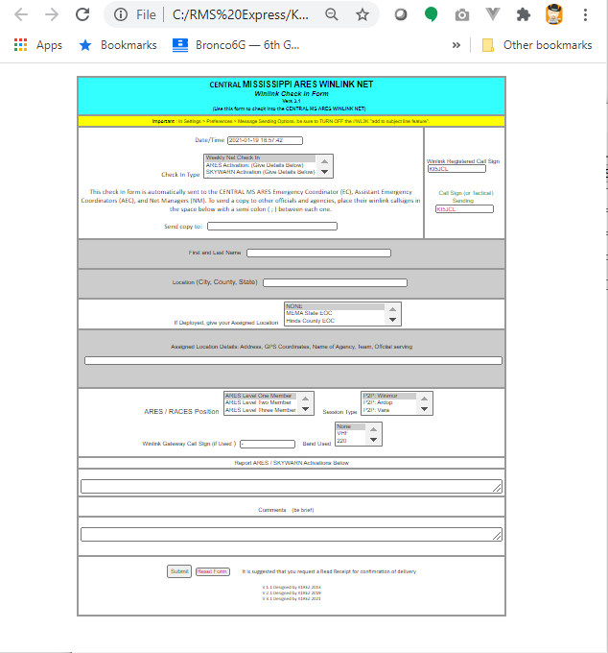
- A message box will appear similar to below, but may vary depending on your browser. Click ok, and close the blank tab in your browser.
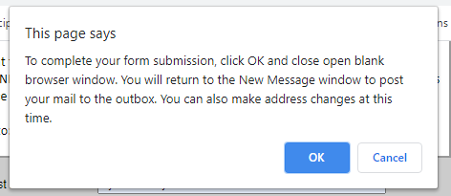
- Now return to your Winlink message window, which should be populated.
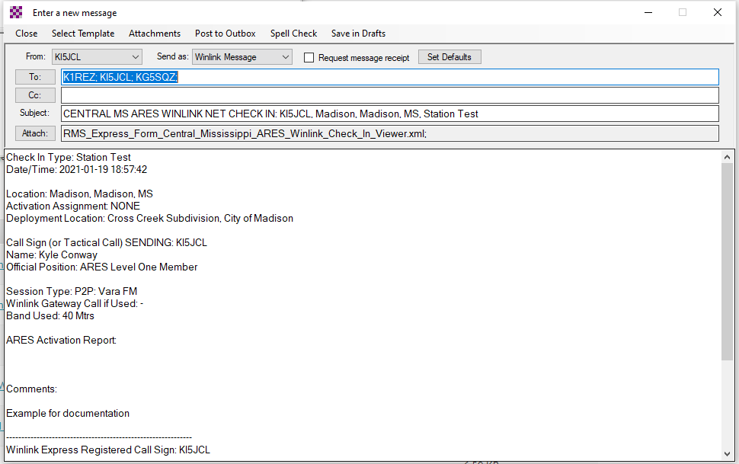
- From this point the message should act like any other. Post to your outbox, then open a session to send the message.

